Use these instructions to set up an account on SecureRelease and request documents from Customs and Border Protection. You will need stable access to the Internet and approximately 30-45 minutes to complete this request. It may take several months for the agency to respond to your request for documents, which is standard given current agency processing times.

**CBP FOIA Request FAQ:**

Step 1. Create an account on https://www.securerelease.us/account-page/sign-in/ . Enter the email you regularly check, select a password, and then enter your phone number, first and last name, your street addres, your zip code, city, state, and country of residence (USA.)

If you are working with a community organization to help you get your documents, provide the organization’s email and phone number but still use your name, and address.

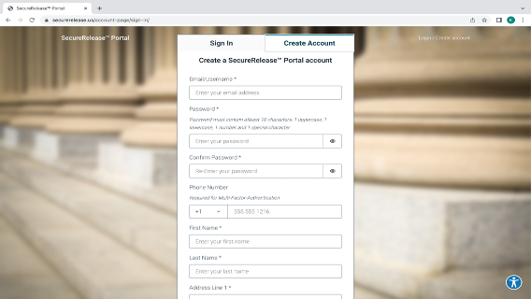

Step 2. click ‘Create Account’.

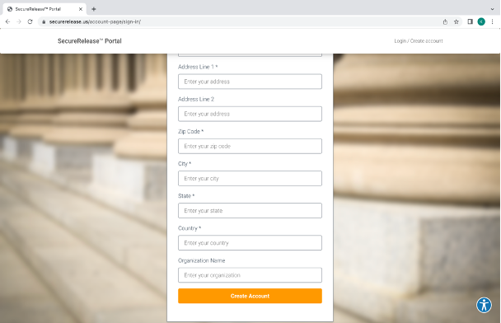

Step 3. Once you click “Create Account,” it will bring you to a new page. On this new page, click on “CREATE REQUEST” to begin your FOIA Request

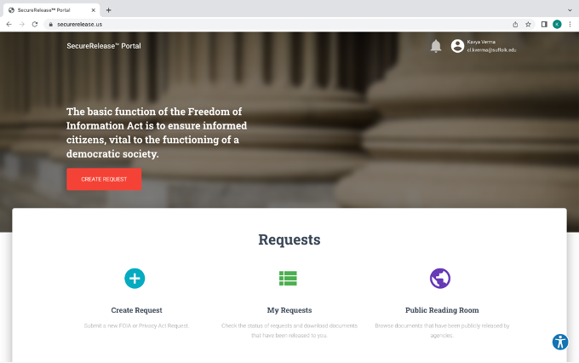



Step 4. In the Agency dropdown, select ‘Department of Homeland Security’

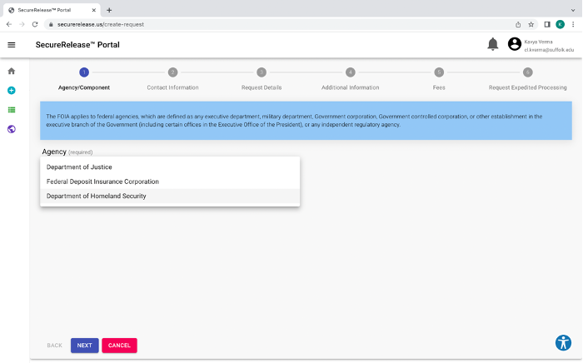

Step 5. In the Component Dropdown select ‘U.S. Customs & Border Protection’. Then click “Next.”

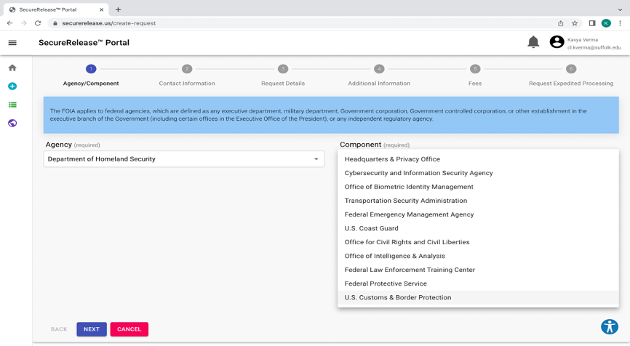



Step 5. On the following page, select ‘FOIA Request’ in the Request Type dropdown.

In the box, indicate that you want all records regarding your arrest by a CBP agent including: Form I-220A, I-213 if it exists, credible fear interview notes and decision. Try to enter an exact date and location or at least a month/year when you were arrested by CBP.

When you are done, click “Next”.

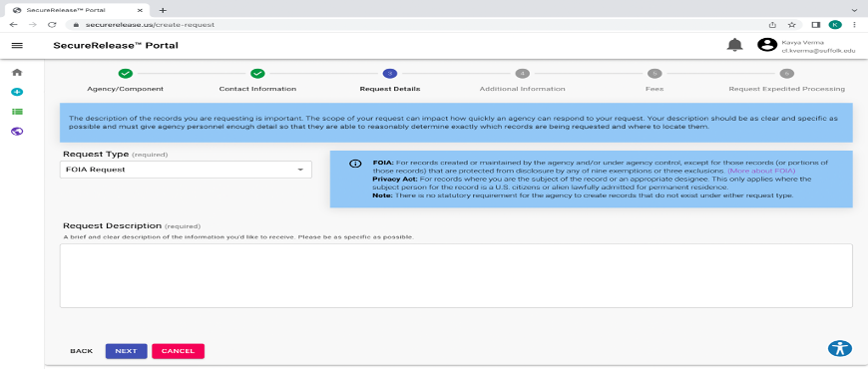

Step 6. If you have any documents from when you were arrested at the border, upload them here. It is fine if you do not have anything. Click Next.

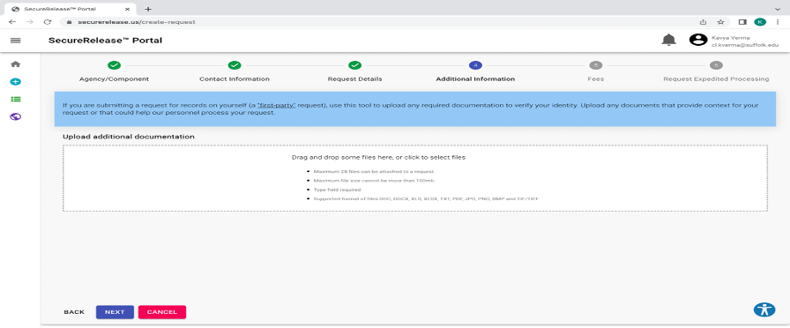

Step 7. Most people are not charged a fee to get their own documents. However, you can also request a fee waiver by checking the box, “Request Fee Waiver.” In the box, write in the reasons you cannot afford a fee. Try and be specific such as “I only earn $200 a month and my rent is $150 a month.”

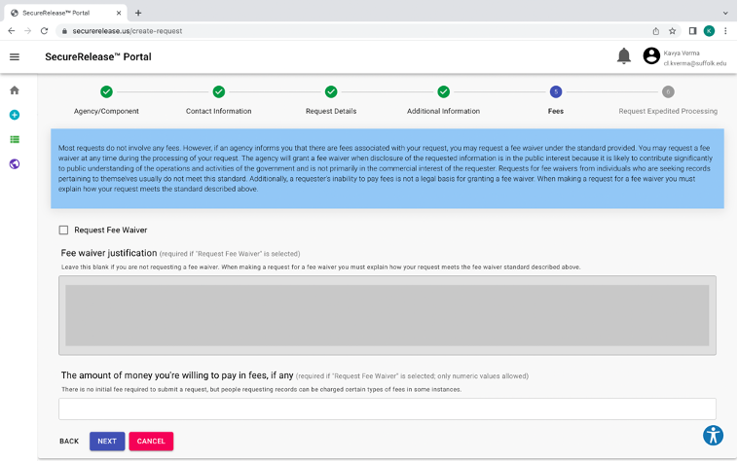

Step 8. Usually, these records take several months to arrive. You can ask for them to come faster if you are in one of two situations:

1. You have an upcoming hearing before an Immigration Judge. If this applies to you, check the box for ‘Request Expedited Processing’ say what you are applying for and the date of your next hearing. Then click ‘Submit Request’, circled below.
2. You don’t have an upcoming hearing but you are afraid you will be deported soon. This applies to people on supervised release where the government has indicated that they plan to deport you. If this applies to you, check the box for Request Expedited Processing’ and write that you are “afraid of a threat to your life or freedom.”

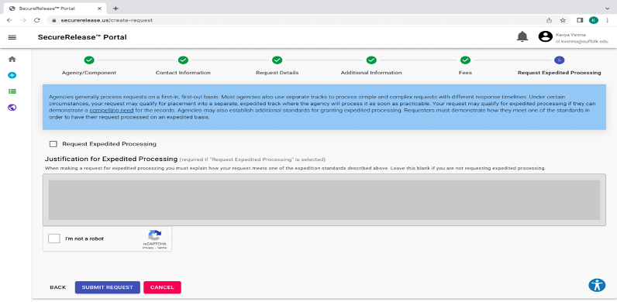

Step 9. Click “Next.”

Congratulations on completing your first request! It may have seemed hard, but getting this information is very important in helping with your case.